Kako narediti
You need to access the amountInput variable in the TipTimeLayout() function to calculate and display the tip amount, but the amountInput variable is the state of the text field defined in the EditNumberField() composable function, so you can't call it from the TipTimeLayout() function yet. This image illustrates the structure of the code:
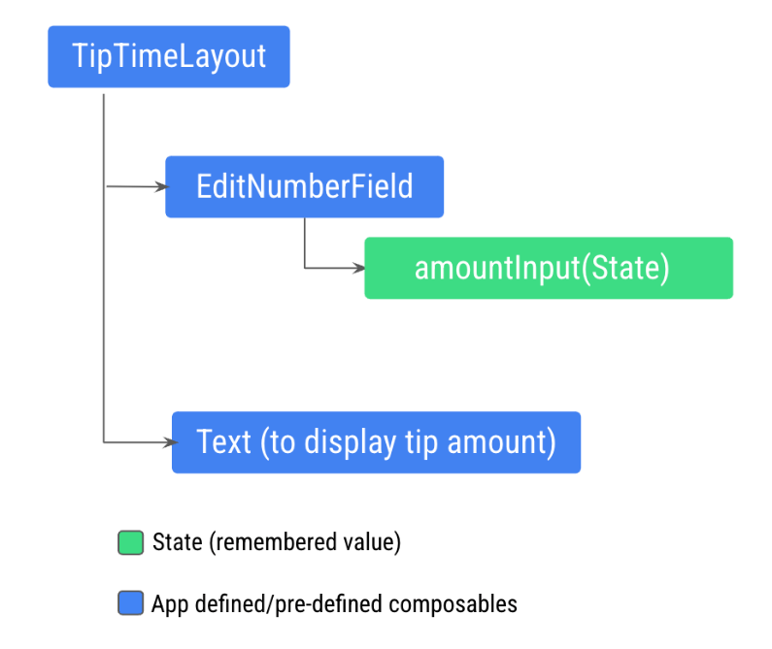
This structure won't let you display the tip amount in the new Text composable because the Text composable needs to access the amount variable calculated from the amountInput variable. You need to expose the amount variable to the TipTimeLayout() function. This image illustrates the desired code structure, which makes the EditNumberField() composable stateless:
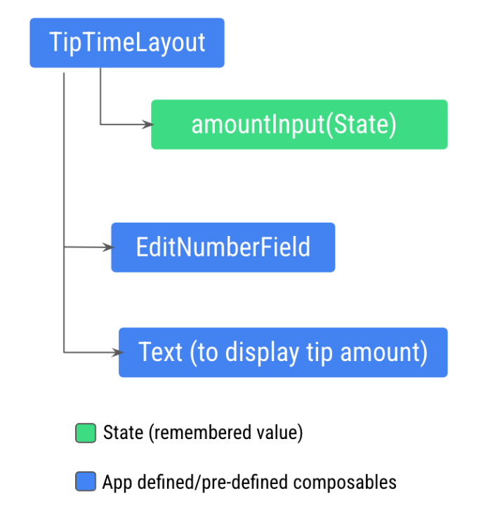
This pattern is called state hoisting. In the next section, you hoist, or lift, the state from a composable to make it stateless.

Note: A stateless composable is a composable that doesn't store its own state. It displays whatever state it's given as input arguments.
Hoisting
In this section, you learn how to decide where to define your state in a way that you can reuse and share your composables.

In a composable function, you can define variables that hold state to display in the UI. For example, you defined the amountInput variable as state in the EditNumberField() composable.
When your app becomes more complex and other composables need access to the state within the EditNumberField() composable, you need to consider hoisting, or extracting, the state out of the EditNumberField() composable function.

Understand stateful versus stateless composables
You should hoist the state when you need to:
- Share the state with multiple composable functions.
- Create a stateless composable that can be reused in your app.
When you extract state from a composable function, the resulting composable function is called stateless. That is, composable functions can be made stateless by extracting state from them.
A stateless composable is a composable that doesn't have a state, meaning it doesn't hold, define, or modify a new state. On the other hand, a stateful composable is a composable that owns a piece of state that can change over time.
Note: In real apps, having a 100% stateless composable can be difficult to achieve depending on the composable's responsibilities. You should design your composables in a way that they will own as little state as possible and allow the state to be hoisted when it makes sense, by exposing it in the composable's API.
State hoisting is a pattern of moving state to its caller to make a component stateless.
When applied to composables, this often means introducing two parameters to the composable:
- Avalue: T parameter, which is the current value to display.
- An onValueChange:(T)->Unit – callback lambda, which is triggered when the value changes so that the state can be updated elsewhere, such as when a user enters some text in the text box.
Prej | Kasneje
@Composable  fun TipTimeLayout()  {  // Composables  Column(  modifier = Modifier.fillMaxSize().statusBarsPadding(),  horizontalAlignment = Alignment.CenterHorizontally,  verticalArrangement = Arrangement.Top  ) {  Text(  "Calculate Tip",  modifier = Modifier.padding(16.dp)  )  EditNumberField(  modifier = Modifier  .fillMaxWidth()  .padding(16.dp)  )  Text(  text="Tip amount: $tip €",  fontWeight = FontWeight.Bold,  modifier = Modifier.padding(16.dp)  )  }  } | @Composable  fun TipTimeLayout()  {  // states  var amountInput by remember { mutableStateOf("") }  val amount = amountInput.toDoubleOrNull() ?: 0.0  val tip = calculateTip(amount)  // Composables  Column(  modifier = Modifier.fillMaxSize().statusBarsPadding(),  horizontalAlignment = Alignment.CenterHorizontally,  verticalArrangement = Arrangement.Top  ) {  Text(  "Calculate Tip",  modifier = Modifier.padding(16.dp)  )  EditNumberField(  value = amountInput,  onValueC = { amountInput = it }  },  modifier = Modifier  .fillMaxWidth()  .padding(16.dp)  )  Text(  text="Tip amount: $tip €",  fontWeight = FontWeight.Bold,  modifier = Modifier.padding(16.dp)  )  }  }
fun EditNumberField(  modifier: Modifier = Modifier  ) {  var vrednostStoritve by remember { mutableStateOf("") }  val vrednost = vrednostStoritve.toDoubleOrNull() ?: 0.0  val napitnina = calculateTip(vrednost)  TextField(  value = vrednostStoritve,  onValueChange = {vrednostStoritve = it},  modifier = modifier  )  } | @Composable  fun EditNumberField(  value:String,  onValueC:(String)->Unit,  modifier: Modifier = Modifier  ) {  TextField(  value = value,  onValueChange = onValueC,  modifier = modifier  )  }

Opis delovanja principa state hosting v zgornjem primeru!

1. Screen starts
Android calls:
TipTimeLayout()
Compose begins initial composition.

2. State is created
var amountInput by remember {
mutableStateOf("")
}
This creates state.
Initially:
amountInput = ""
(empty string)

3. amount is calculated
val amount = amountInput.toDoubleOrNull() ?: 0.0
Currently:
amountInput = ""
So:
"".toDoubleOrNull()
returns:
null
Therefore:
amount = 0.0

4. Tip is calculated
val tip = calculateTip(amount)
Now:
calculateTip(0.0)
returns:
0.00

5. EditNumberField is called
Compose executes:
EditNumberField(
value = amountInput,
{ amountInput = it }
)
VERY important.
You are passing TWO things:

A) current value
value = amountInput
Currently:
""

B) function/lambda
{ amountInput = it }
This is callback function.
Equivalent to:
onValueChange = { newText ->
amountInput = newText
}

6. Inside EditNumberField
Compose enters:
fun EditNumberField(
value:String,
onValueChange:(String)->Unit
)
Now local variables become:
value = ""
onValueChange = lambda function

7. TextField is built
TextField(
value = value,
onValueChange = onValueChange
)
Equivalent to:
TextField(
value = "",
onValueChange = { amountInput = it }
)

NOW IMPORTANT PART

User types "5"
Android keyboard sends:
"5"
to:
TextField.onValueChange
So this executes:
onValueChange("5")
But what IS onValueChange?
It is THIS lambda:
{ amountInput = it }
Therefore:
amountInput = "5"

VERY IMPORTANT
Changing:
amountInput
changes STATE.
Compose observes state changes.
So Compose says:
"Oh, state changed.
I must recompose."

8. Recomposition happens
Compose reruns:
TipTimeLayout()
AGAIN.
Not whole app.
Only affected composables.

9. New values
Now:
amountInput = "5"
Therefore:
amount = 5.0
Then:
tip = 0.75
Then Text becomes:
Tip amount: 0.75 €
UI updates automatically.

COMPLETE DATA FLOW
User types
↓
TextField calls onValueChange
↓
Lambda changes amountInput
↓
State changes
↓
Compose recomposes
↓
Tip recalculated
↓
UI updates
THIS is the heart of Compose.

MOST IMPORTANT ARCHITECTURAL IDEA
Your EditNumberField() does NOT own state anymore.
It only:
- displays value
- notifies changes
Parent owns state:
TipTimeLayout
This is correct Compose architecture.

Why this is GOOD
Because parent now controls everything:
- calculations
- validation
- saving
- formatting
- business logic
Child composable becomes reusable.
You can now reuse:
EditNumberField()
ANYWHERE.
Because it is stateless.

vir: link

